Christmas Report!

MERRY CHRISTMAS!!!

Here are some of the things I have done – but first, the questions you’ve asked!

1. The Morse Potential –

I’ve used the HCl molecule – here are some sample energy levels from my plot.

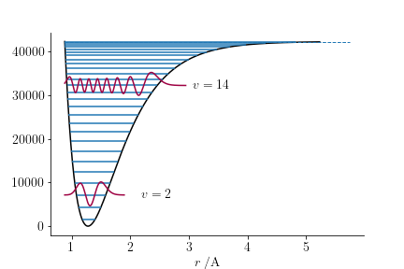

I attempted to solve this in two ways – one, by using a numerical method, and the other, by using the analytical solutions.

1. The qubits –

The current biased qubit has the following potential function:



Where Ib/Ic is a constant factor. I’ve calculated and plotted the states, KE and PE operators:

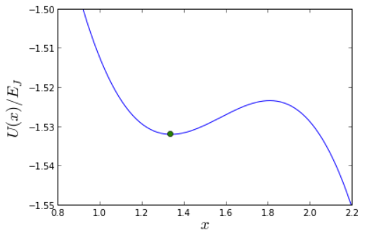

The dot represents the minima in my potential with chosen factors.

The first few eigenstates are –

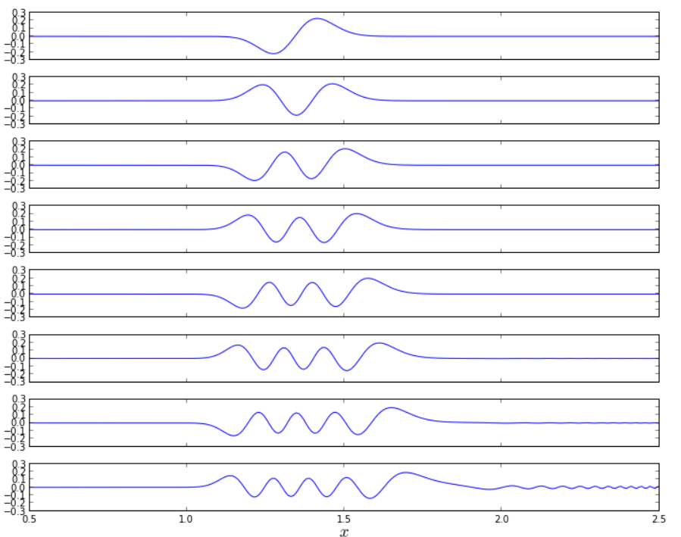

So it really looks like

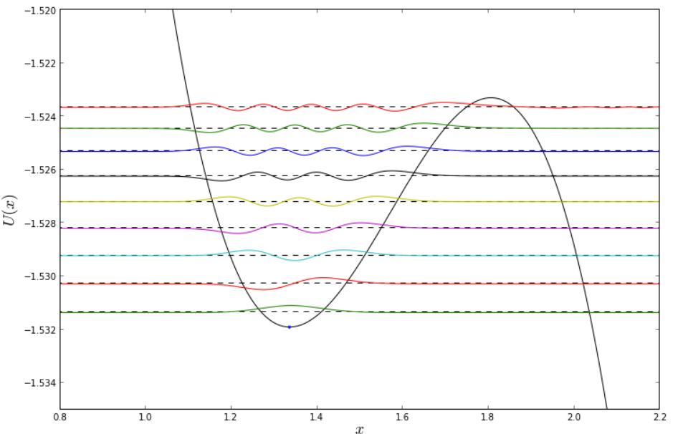

Now, the other qubit is the flux biased one, which really refers to a potential of the form –



Beta and gamma are constants (apparatus based, much like Ib and Ic)

Here, I show the same 3 graphs –

The potential –

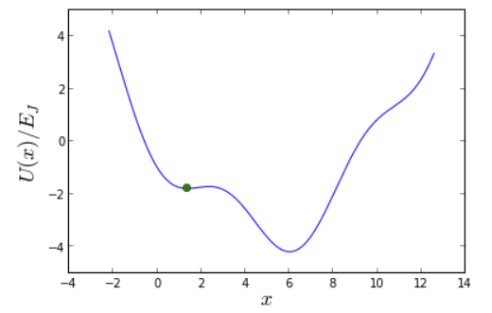

The eigenstates –

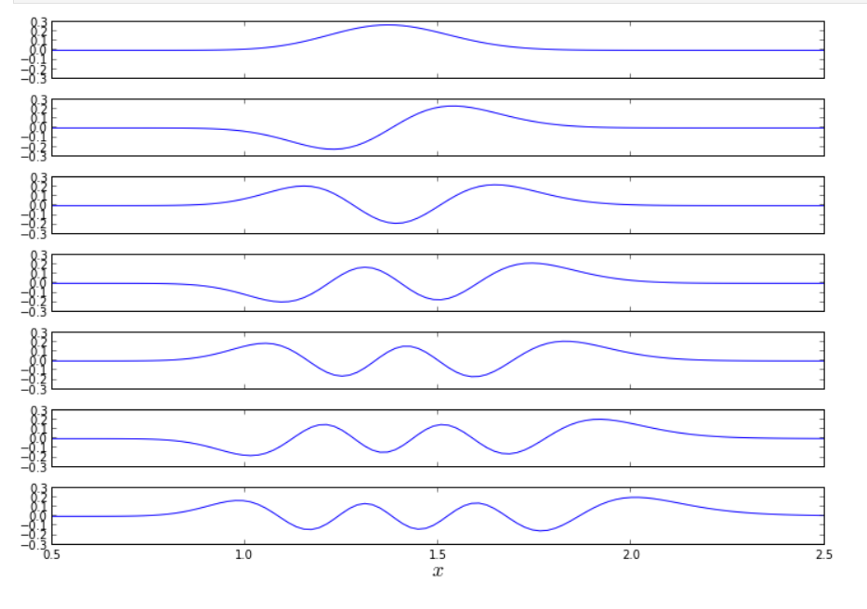

And the full course –

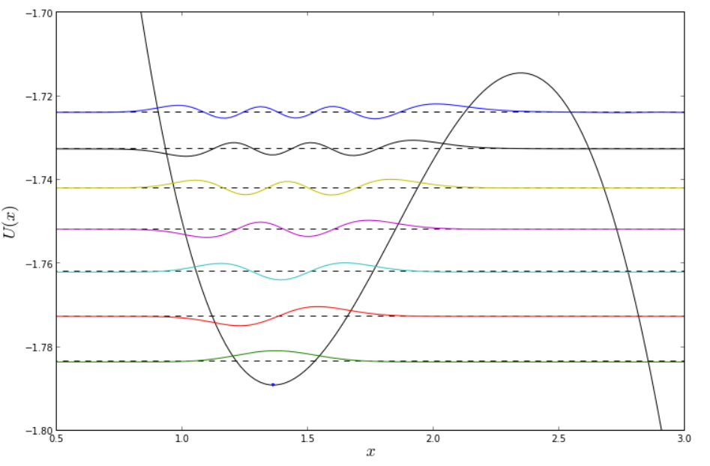

I’ve zoomed in a bit to make things clearer.

All solutions have been obtained numerically.

1. How am I selecting points for the 2D SHO?

I’m following this tutorial –

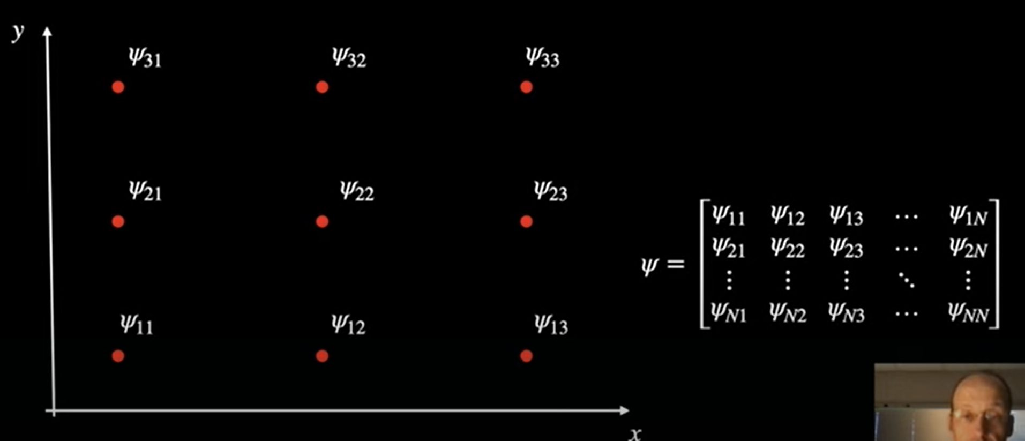

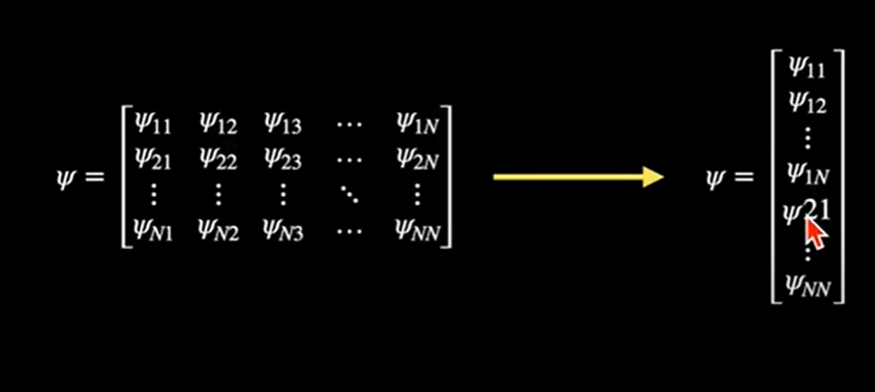

Of course, boundary condition of the wavefunction going to 0 at all extremes is implemented.

This results in me solving –

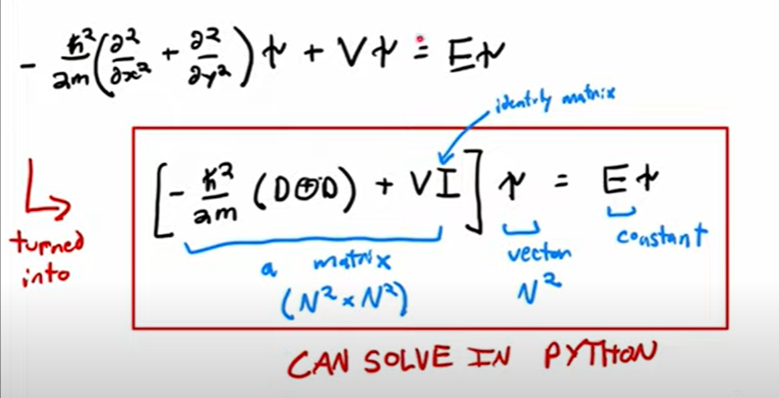

Of course, the alternate was for me to simply plot the solutions of the 2D SHO, but I wanted to understand how to numerically solve any 2D potential.

# Problems:

I’m still getting some odd matrix errors. I’ve attached my B, B’ , C and U for both the numeric and analytic cases of Morse Oscillators.

In the numeric case, my method works thus – if I want 10 eigenfunctions, it gives me these 10 functions sampled at 10 points each. But, for B’, I need the 11th wavefunction, sampled at 10 points as well. I explored solving for 20 wavefunctions sampled at 20 points, and then only retaining 10 points by skipping every alternate point to have just 10 points each.

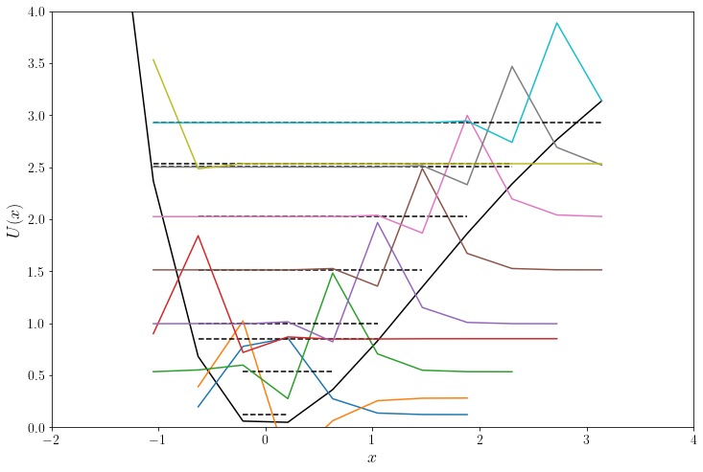

In my analytic case, the tutorial and ideas I followed automatically prune the wavefunctions at the turning points – thus, my ground state wavefunction may have around 100 points, and my 5th state wavefunction around 160. The number of points depends upon the resolution of my potential, i..e if I represent it as a 10x10 matrix or a 1000x1000 one. (This NxN matrix is basically a potential evaluated over an NxN grid of internuclear separations – the 1000x1000 grid naturally has more accurate than the coarse 10x10 grid)

At first, I attempted to simply sample the potential as a 10x10 matrix, but this gave me horrendous results –

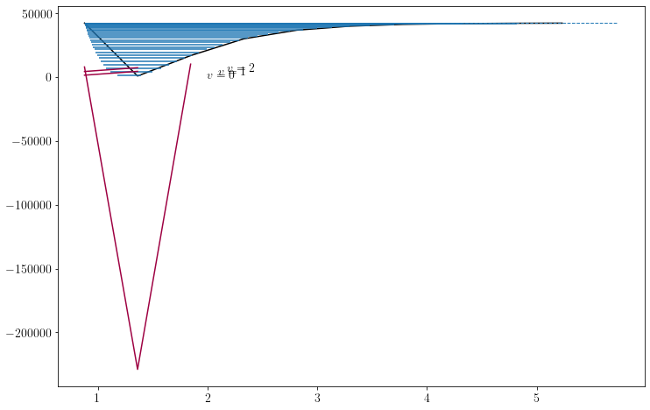

Then, I decided to sample the potential as a 1000x1000 matrix, and obtained –

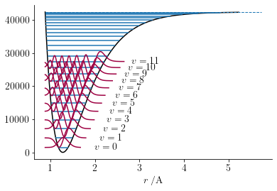

The primary issue is that the wavefunctions are all composed of a different number of elemnets, for eg. The v = 0 state has ~300 points, and the v = 10 state has ~600 points in its representation. I chose to condense them to 10 points each, by choosing uniformly from the available points, giving me a B matrix of 10x10 dimensions – i.e, 10 wavefunctions, sampled at 10 points each. For the potential to be transformed as U, I observed that the V in the 10x10 matrix representation was actually quite good and used that, to obtain V = 10x10 matrix, and hence U = B^-1 V B (note – the potential is 1Dd, so I represent V as a 10x10 diagonal matrix)

While making this report, I stumbled upon errors in my code – namely, the potentials seemed a bit off, and C was an identity matrix. After a short break, I’ll resume work upon them. Merry Christmas!

(PS – All in all, I’ve managed to plot the states for Morse oscillators (numerically and analytically), flux and current biased qubits, and am working on plotting and solving for 2D potentials generally. I read up on the theory of the same, brushing up my concepts in the process.